NFS LAB
- Create two instance with SG (ssh 22 and NFS 2049)
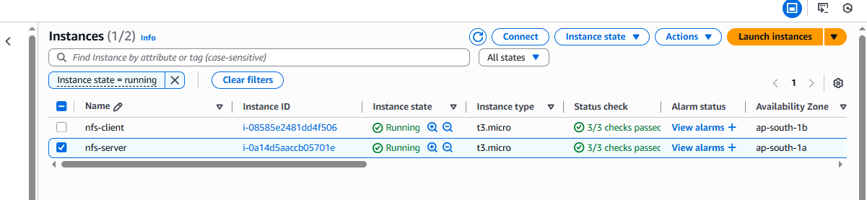
Perform the below command on NFS server
yum -y install nfs-utils
service nfs-server start
systemctl status nfs-server
mkdir /exports
mkdir /exports/backups

vi /etc/exports
/exports/backups *(rw,sync,no_subtree_check) ###-----------(* can be nfs-clien IP)
:wq!
exportfs -ar
exportfs -v
Perform the below command on NFS client.
yum -y install nfs-utils

mkdir -p /mount/backups
mount 172.31.33.7:/exports/backups /mount/backups ----------------------- ###(172.31.33.7 - private IP of nfs server)

Final output
NFS server
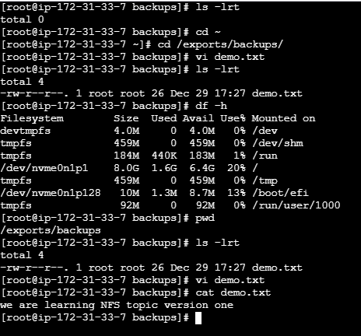

NFS Client
